**STEP 1:** Open task manager with **CONTROL SHIFT ESCAPE**

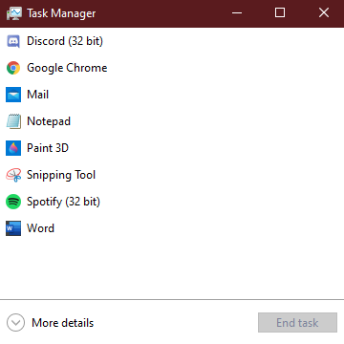**STEP 2:** if your task manager looks like this, click more options

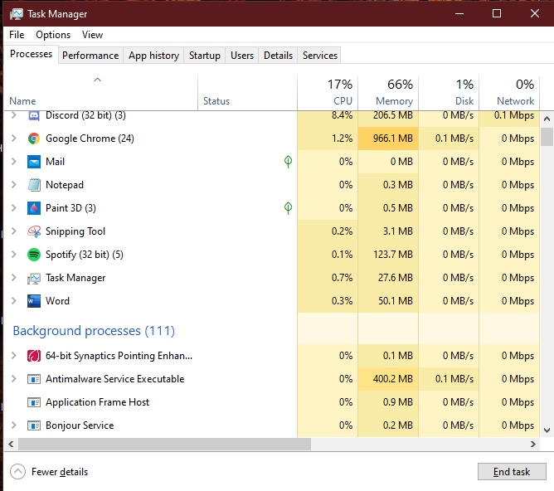

**STEP 3:** click on any task in the **BACKGROUND PROCESSES SECTION** and click your **M** key

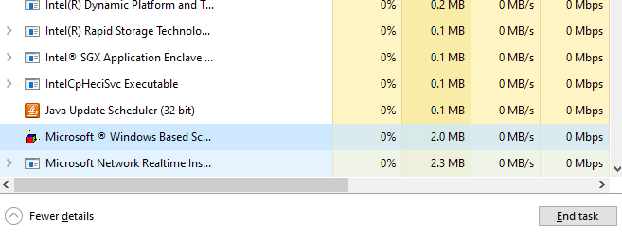

**STEP 4:** It should come up with something like this. If its anything different, keep tapping m until it comes up.

**STEP 5:** Close this task